Eurasian National University named after L.N. Gumilyov

Faculty of «Information Technologies»

Department of «Information Systems»

**Labaratory work: 2**

**by discipline** «Development of client server IS»

**Student:** Iskakov Y.K.

**Group:** IS-35

**Checked by:** PhD. Akhmetova. A.Z.

**Laboratory work № 2. ESTABLISHING A CONNECTION TO MICROSOFT SQL SERVER AND PRINCIPLES OF CREATING DATABASES**

Option №.5 DB – Travel agency.

**Purpose of the laboratory work:** Learn the basic principles of creating a database in MS SQL Server. Learn the operations performed with databases in general. Get skills in using the "SQL Server Management Studio" program to create, delete, register, connect, extract metadata, backup and restore a database. Learn SQL operators for creating, connecting and deleting a database. Learn the basic principles of managing accounts and roles.

Tasks.

1. **Create a database file according to the option number given in Lab 1 using the SQL command.**

Figure 1.1 Window of the creation of new database

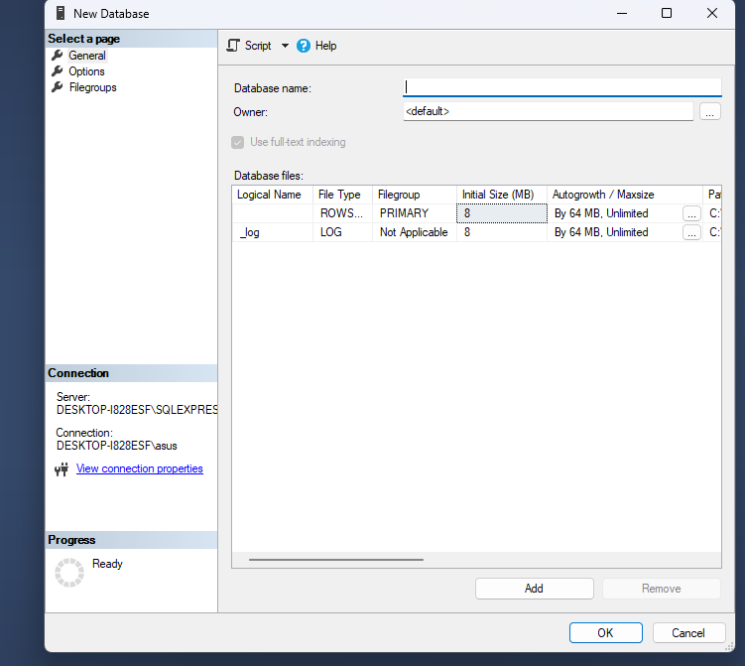

Figure 1.2 Window of the Object Explorer

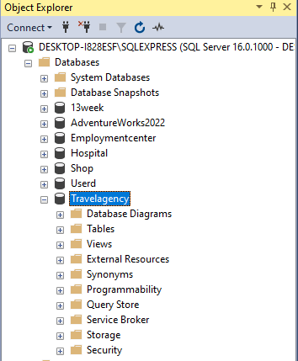

1. **Create a backup copy of the database.**

Резервное копирование базы данных – единственный надежный способ предохранить данные от потери в результате поломки диска, сбоев электропитания, действий злоумышленников и ошибок в программах.

Figure 2.1 Window of the creation of database back-up

Figure 2.1 Window of the back-up database completed succeed

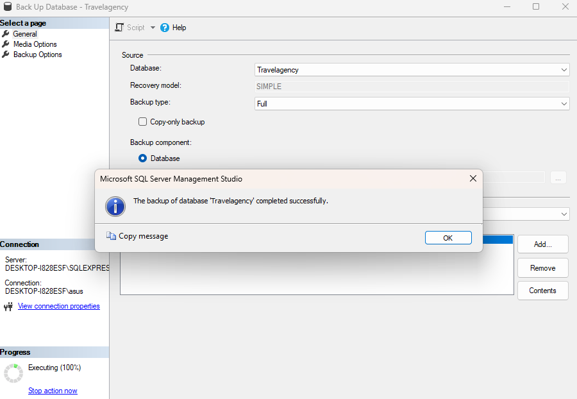

1. **Determine 2-3 officials who will be able to work with the DB tables. For each official, determine the set of privileges that he/she can use.**

Figure 3.1 Window of the add user

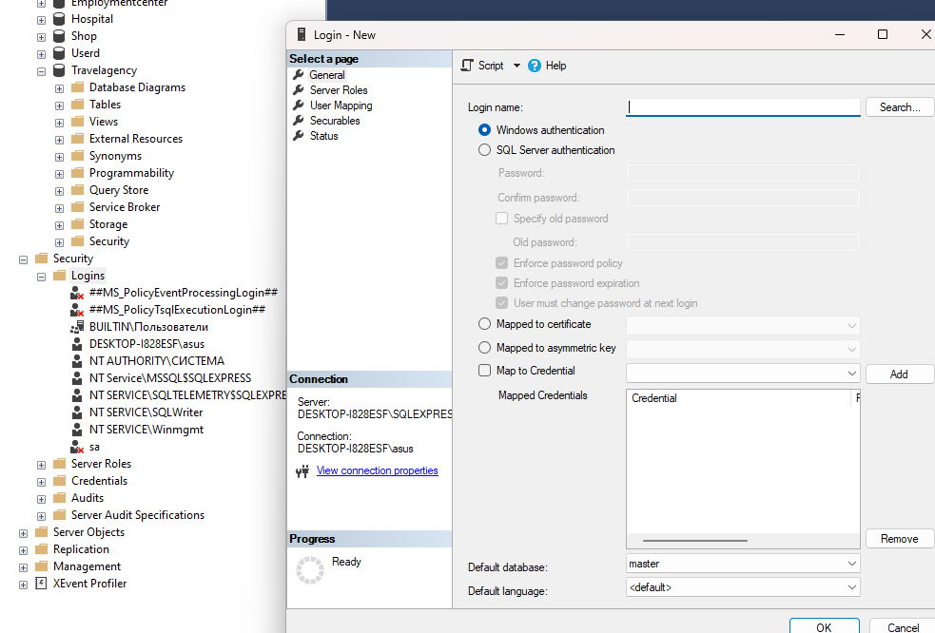

Figure 3.1 Window of the added users

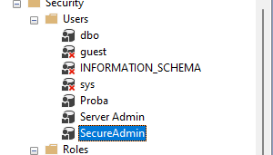

1. **In the SQL Server Management Studio utility, create a corresponding role for each official, grant this role certain privileges. Then create one user for each position and assign them the corresponding roles.**

Figure 4.1 Window of the Tourists permission

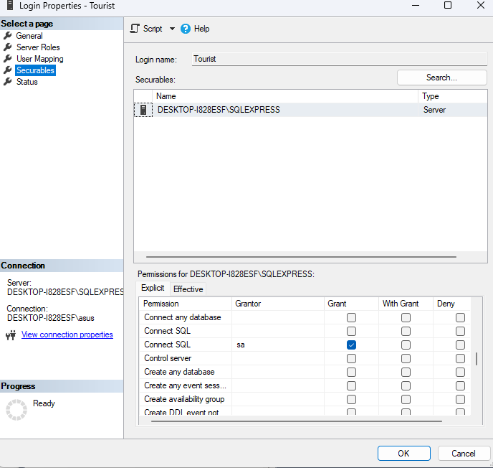

DROP DATABASE Travelagency;

1. Save the SQL operators sequentially with the assignments in a file called Student_LastName_Lab_2

**References**